Order Of Service

Singing: Psalm 19—CW page 70

Reading: Psalm 105:23-36

Opening Hymn: TLH 27

Reading: Acts 22:6-16

Request Hymn: CW Supplement 735

Reading: Matthew 9:27-34

Sermon Hymn: TLH 23

Sermon Text: Mark 9:9-13

As It Is Written

Prayer

The Apostles’ Creed, TLH page 12

Holy Communion

The Lord's Prayer

The Blessing

Closing Hymn: TLH 47

* * * * * * * * * * *

Bible Study: Lambs: Woodcock
Sheep: Proverbs 19:26-29
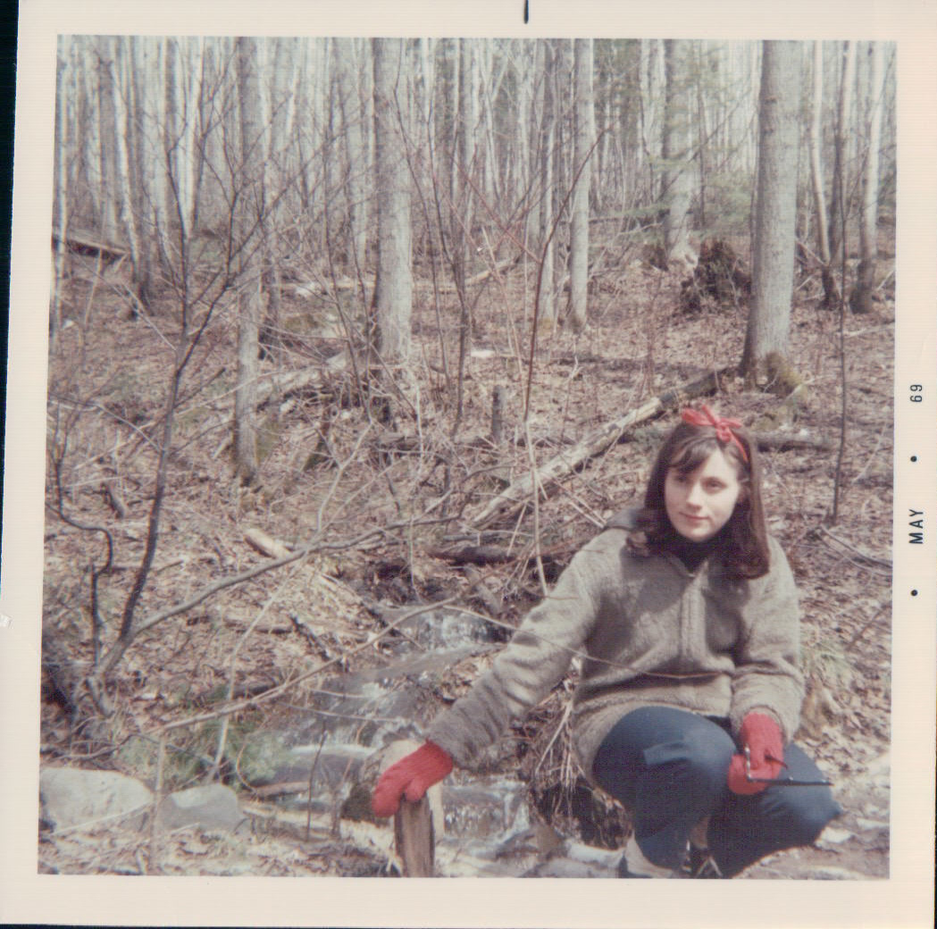

Early Spring—Baptism River

Water
Of
Life

25 August 2019

W A T E R O F L I F E

Independent Christian Church—Conservative Lutheran Doctrine

Worship Service: 9:30 a.m. Bible Study: 10:45 a.m.

Larry Cooper, Pastor E-Mail address:
111 N. Ridge Road lcooper@wateroflife.cc
Coon Valley, WI 54623 Web Site:
www.wateroflife.cc

* * * * * * * * * * * * * * * * * * * * * * * * * * *

Sermon Text: Mark 9:9-13

As It Is Written

* * * * * * * * * * * * * * * * * * * * * * * * * * *

Mark 9:9 And as they came down from the mountain, he charged them that they should tell no man what things they had seen, till the Son of man were risen from the dead.
:10 And they kept that saying with themselves, questioning one with another what the rising from the dead should mean.
:11 And they asked him, saying, Why say the scribes that Elias must first come?
:12 And he answered and told them, Elias verily cometh first, and restoreth all things; and how it is written of the Son of man, that he must suffer many things, and be set at nought.
:13 But I say unto you, That Elias is indeed come, and they have done unto him whatsoever they listed, as it is written of him.
